**DAY 4**

**BUILDING DYNAMIC FRONTEND COMPONENTS FOR MY MARKETPLACE[Sofa-Market]**

**"Key Components Built for a Seamless E-Commerce Experience"**

**- Header, Navbar & Footer for consistent navigation.  
- Product Cards and Details pages for dynamic product data.  
- Shop Now, Cart and Checkout components for seamless shopping.  
- Related Products and Social Sharing to encourage engagement.  
- Contact us Page for user feedback and complains.**

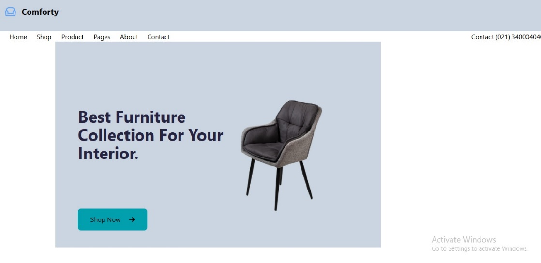k.

